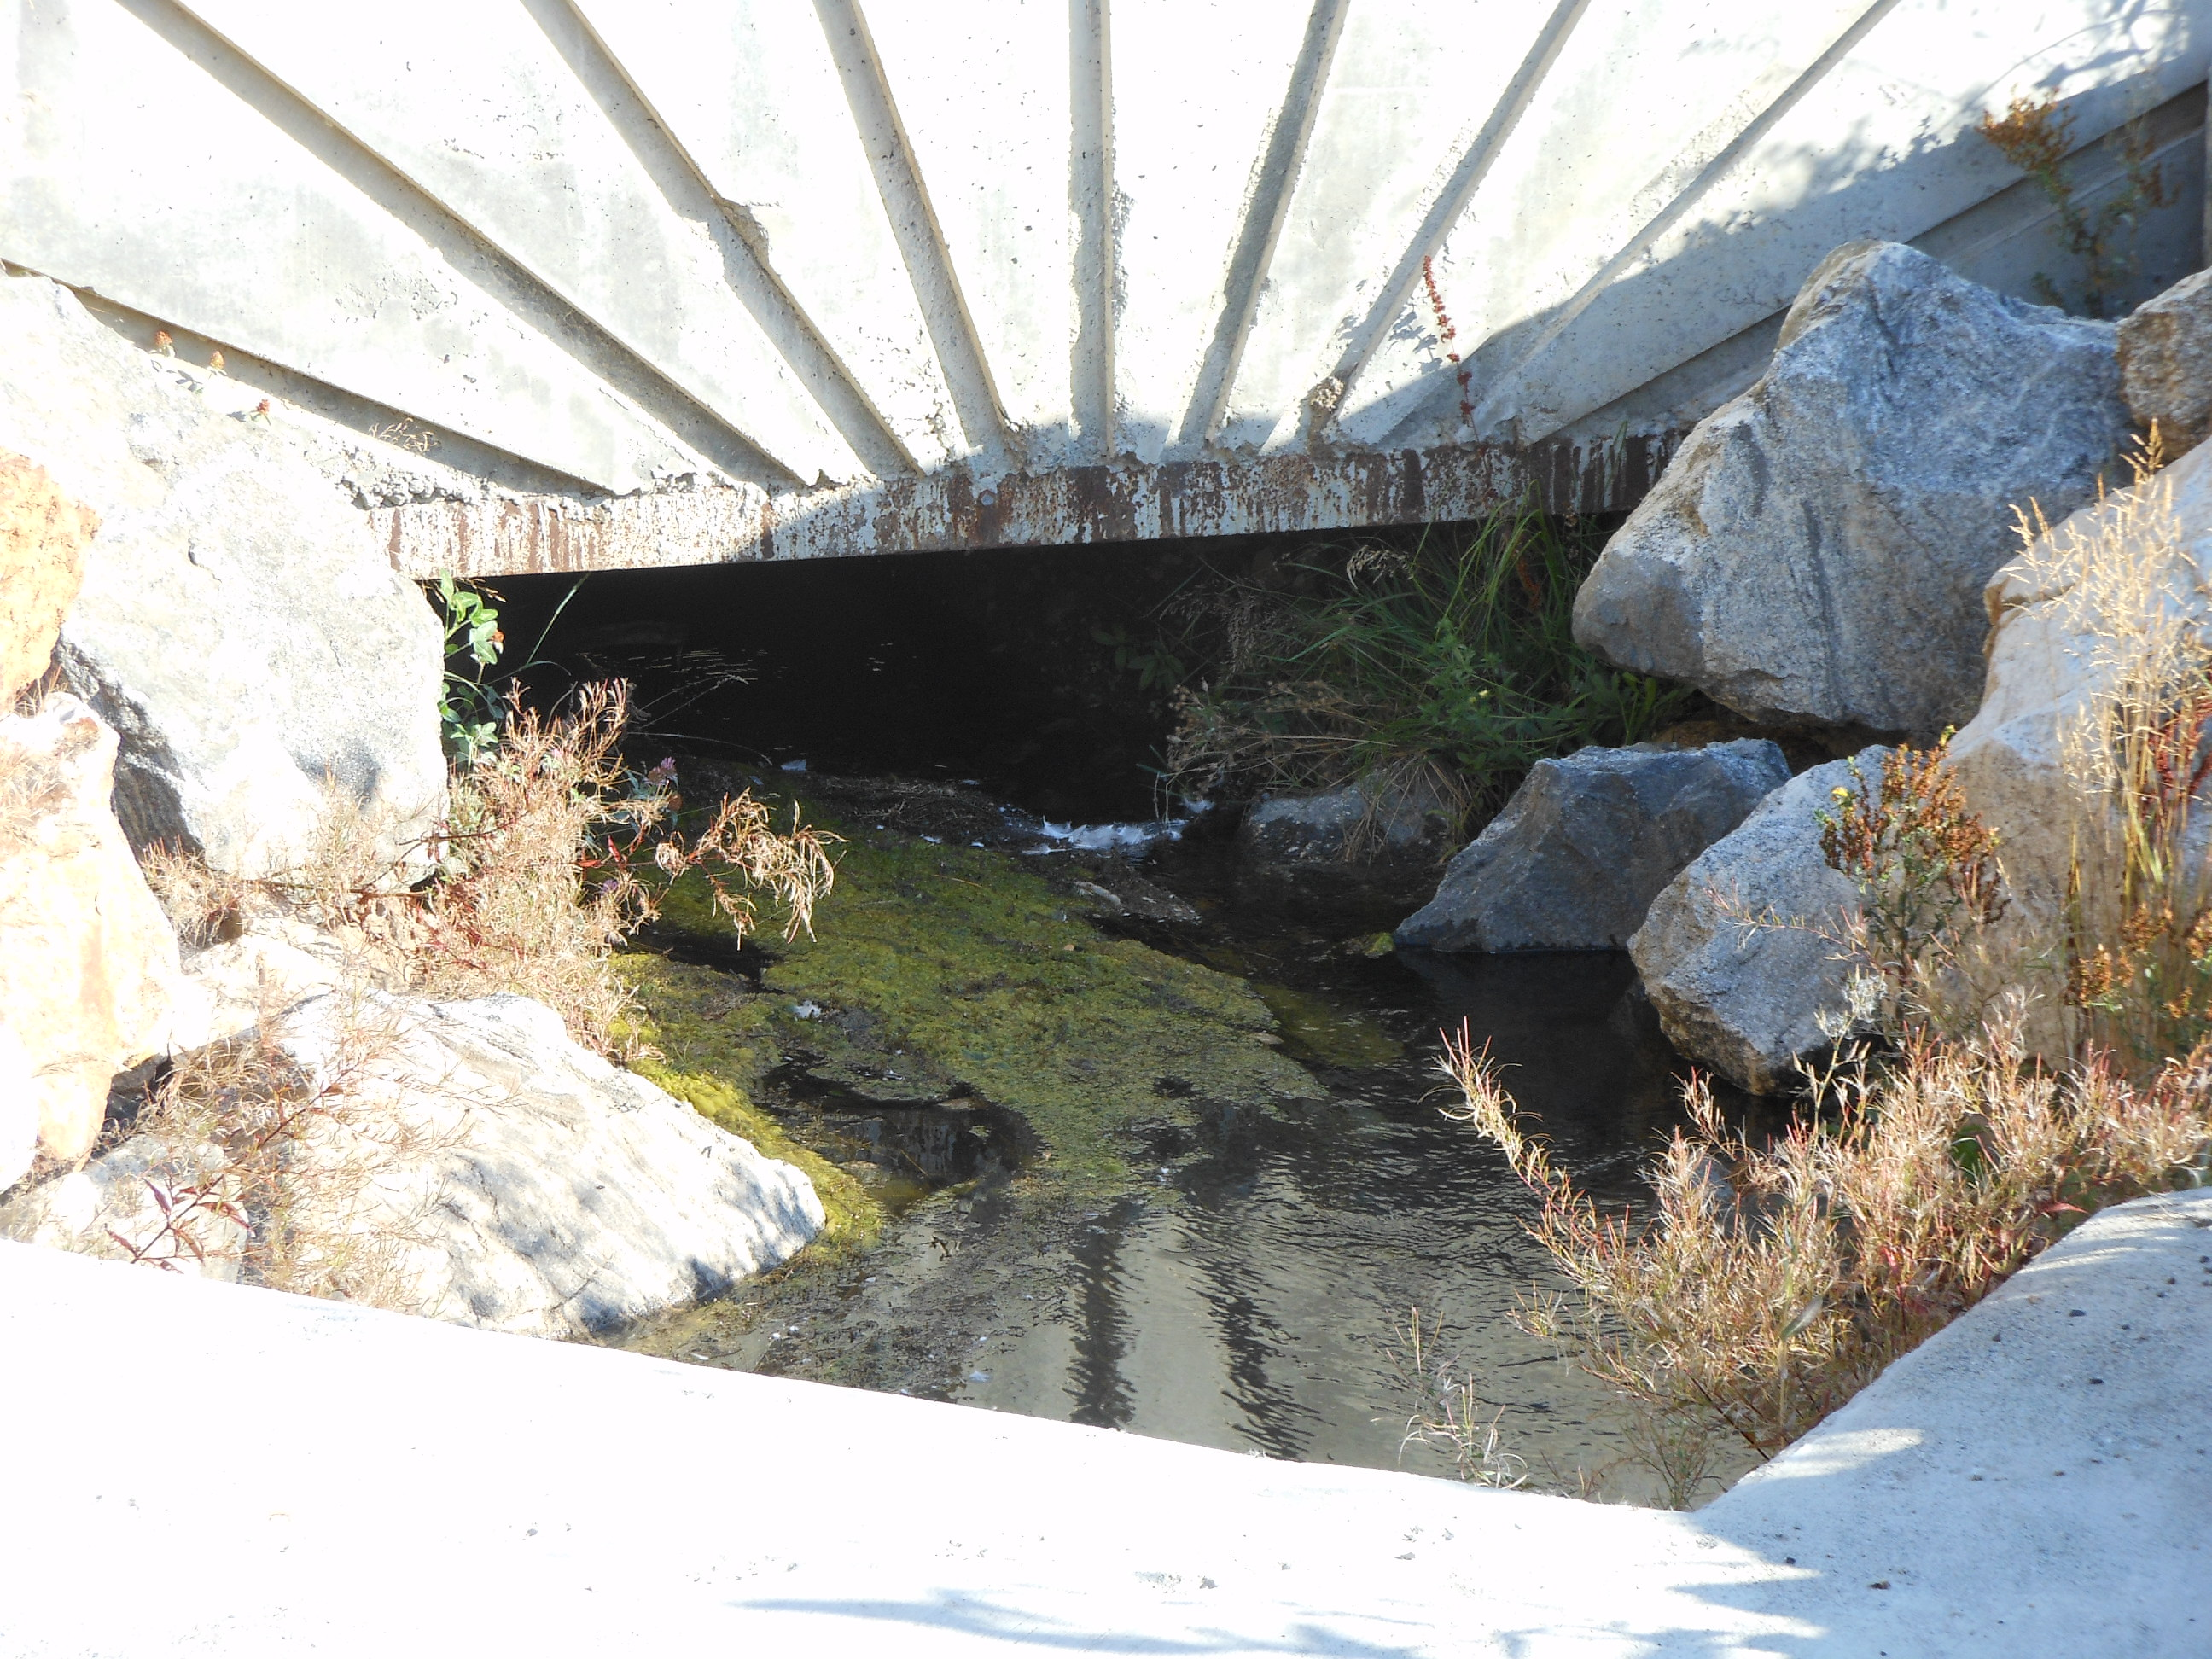
This is the stream bed that connects pond #2 (new pond) with the concrete pool, the pool has a culvert in the center of it buried underground that feeds the bottom pond. The bottom pond then feeds back into the creek (9-27-2011).

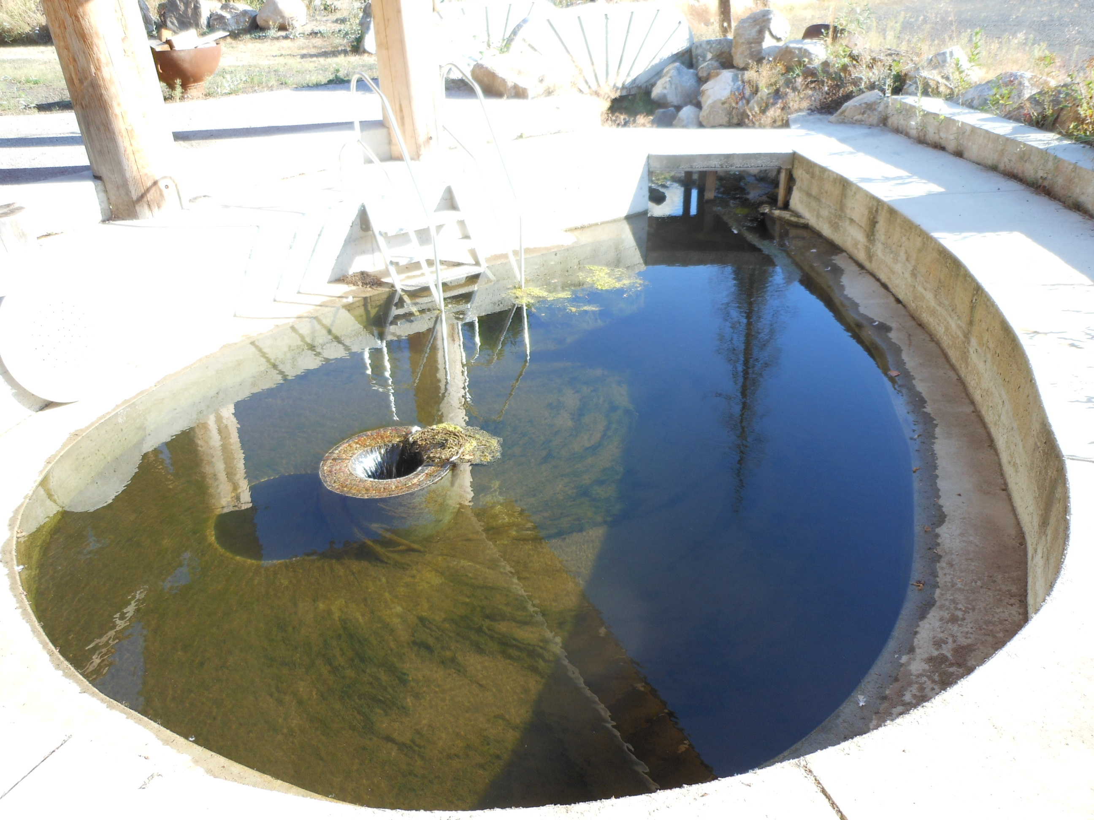
Pond #3 - 2003: This shows the concrete pool with the center culvert, We use it to capture as much algae as possible (9-27-2011).
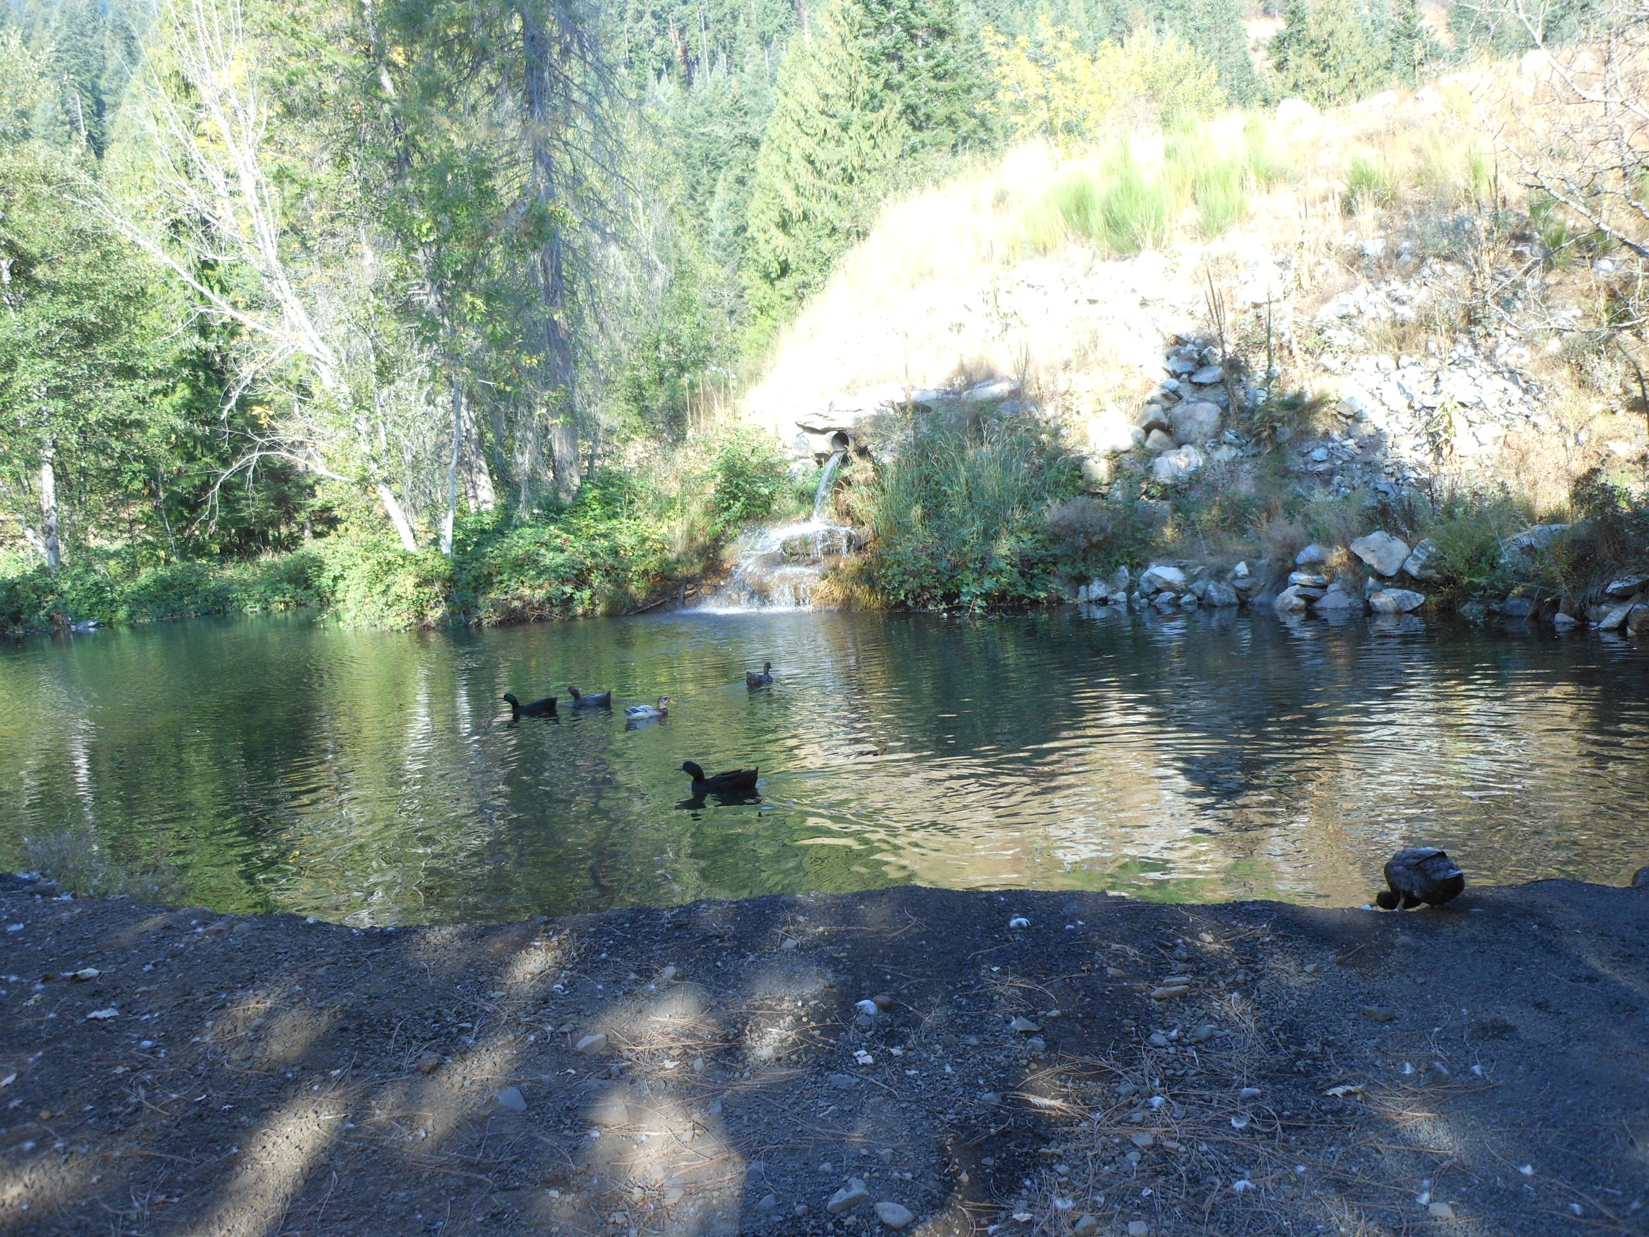
Pond #4 – 1970’s: This shows the lowest pond from the East end. It shows the culvert spilling into it (9-27-2011).
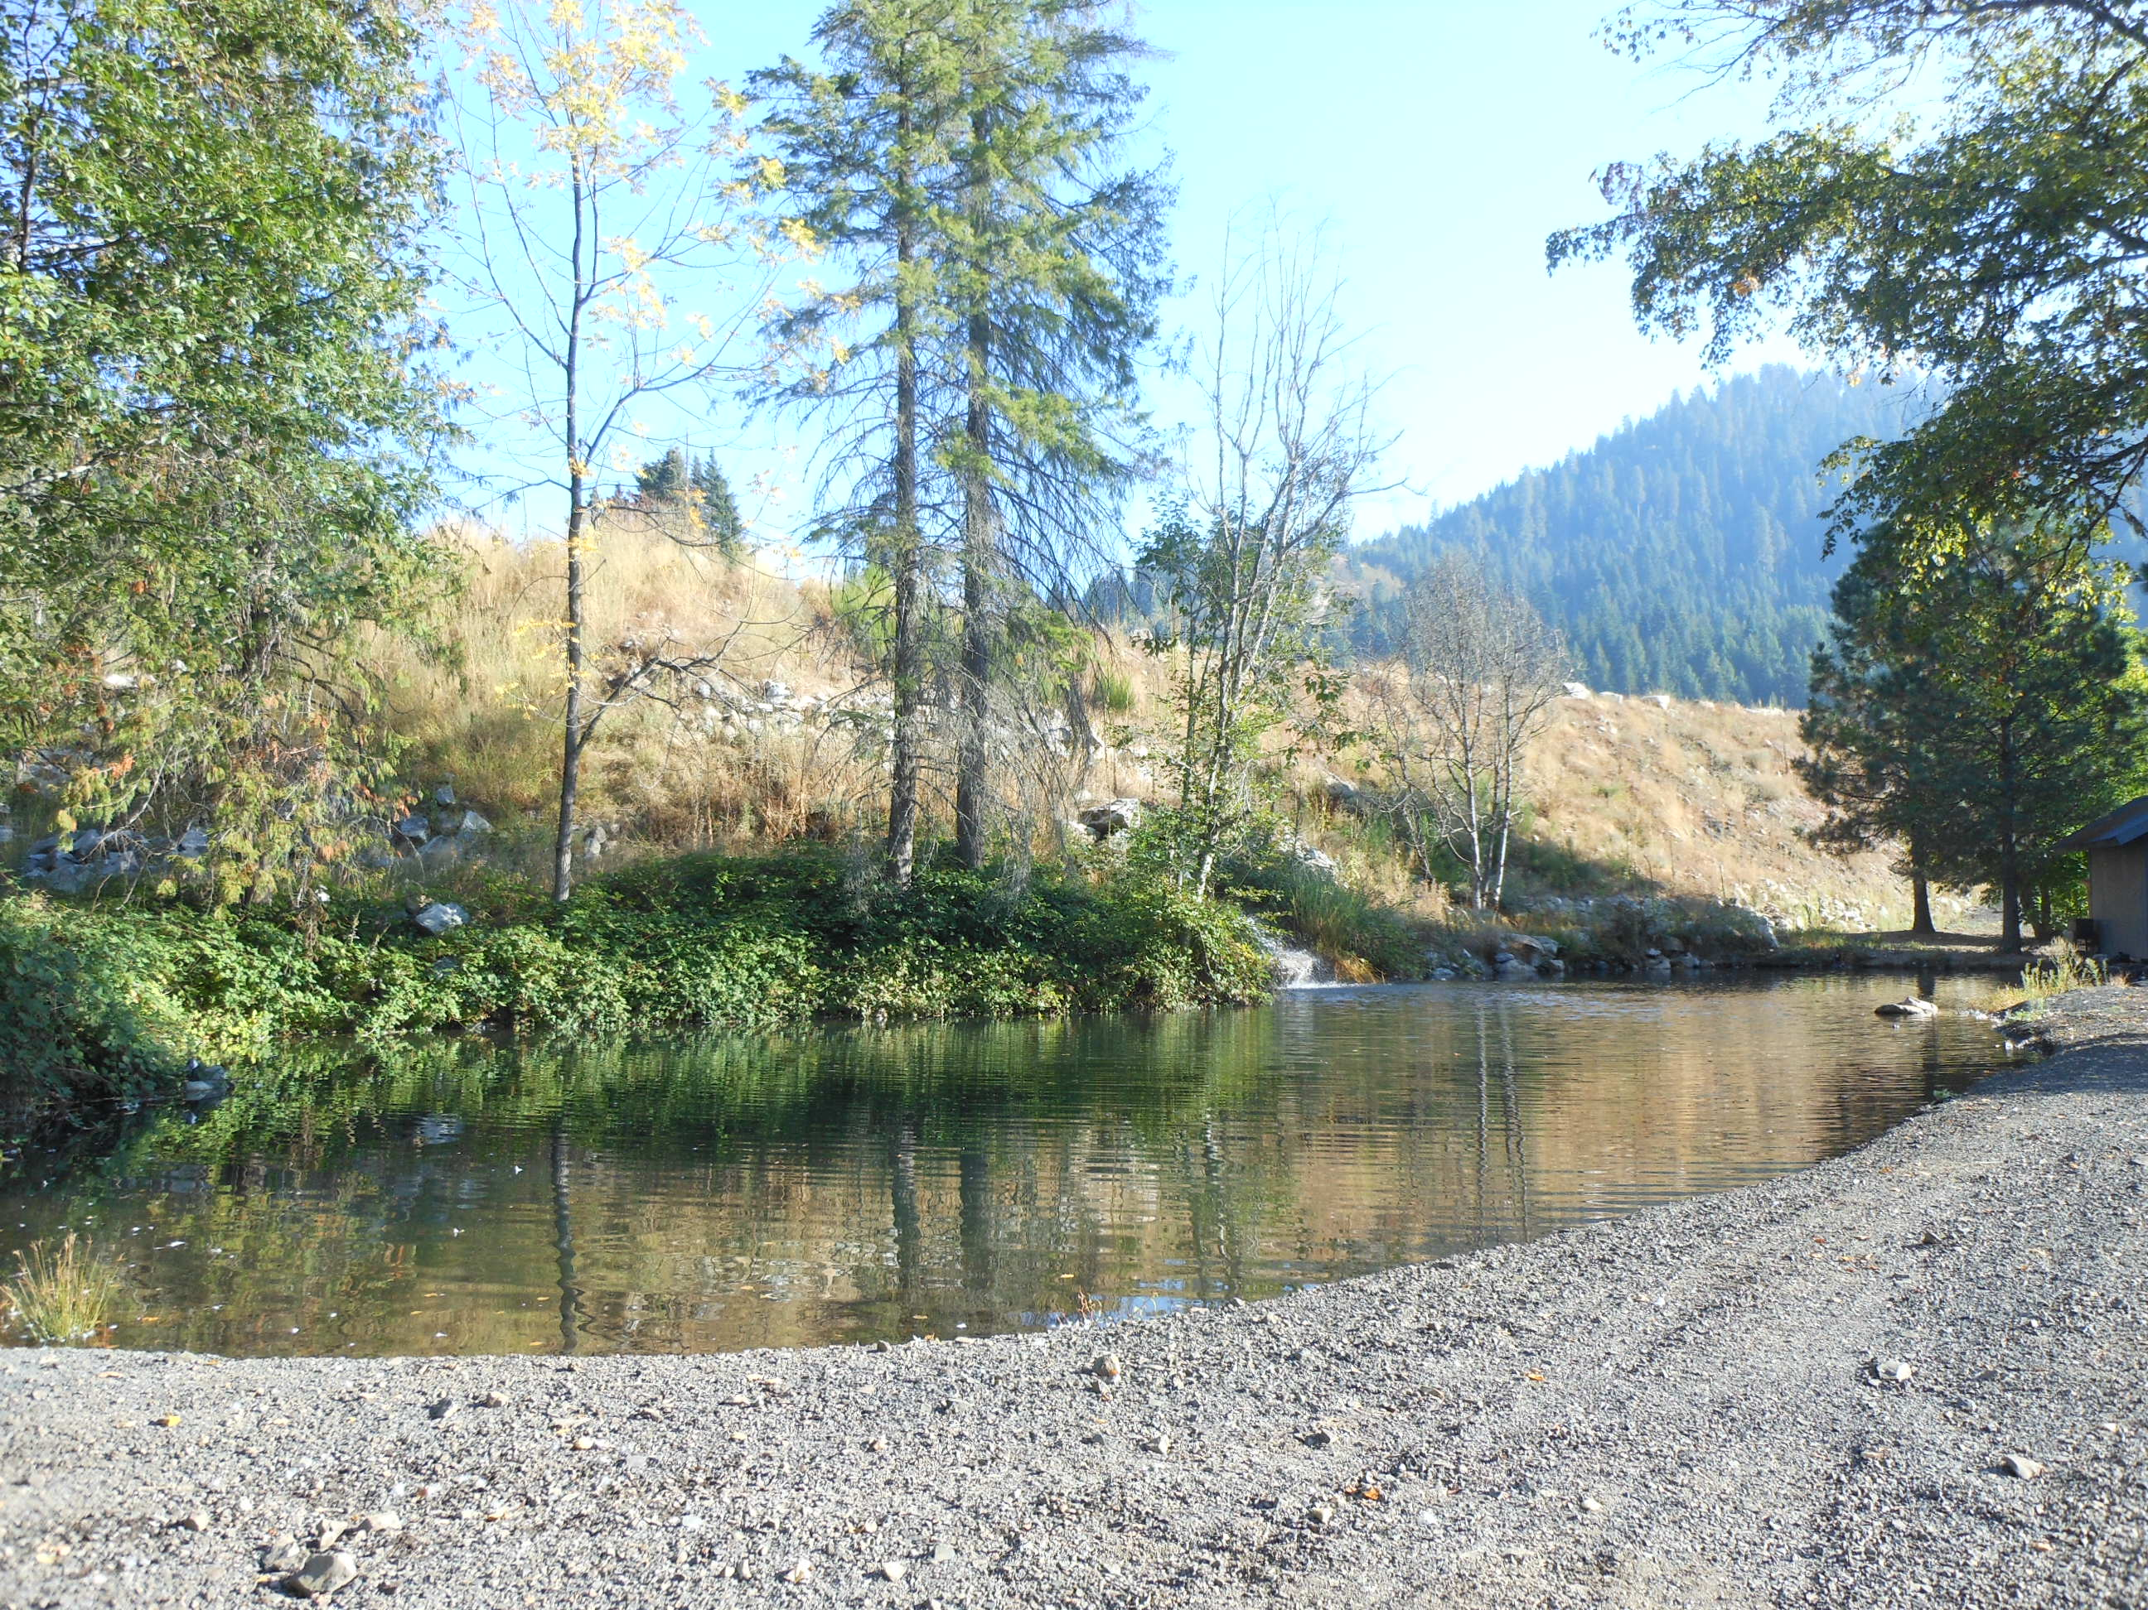
Pond #4 – 1970’s: This shows the same pond (as above from the other end. The lower pond is the one that host my ducks, geese and also wild ducks such as mallard, wood ducks, etc. Canadian geese have found it too (9-27-2011).

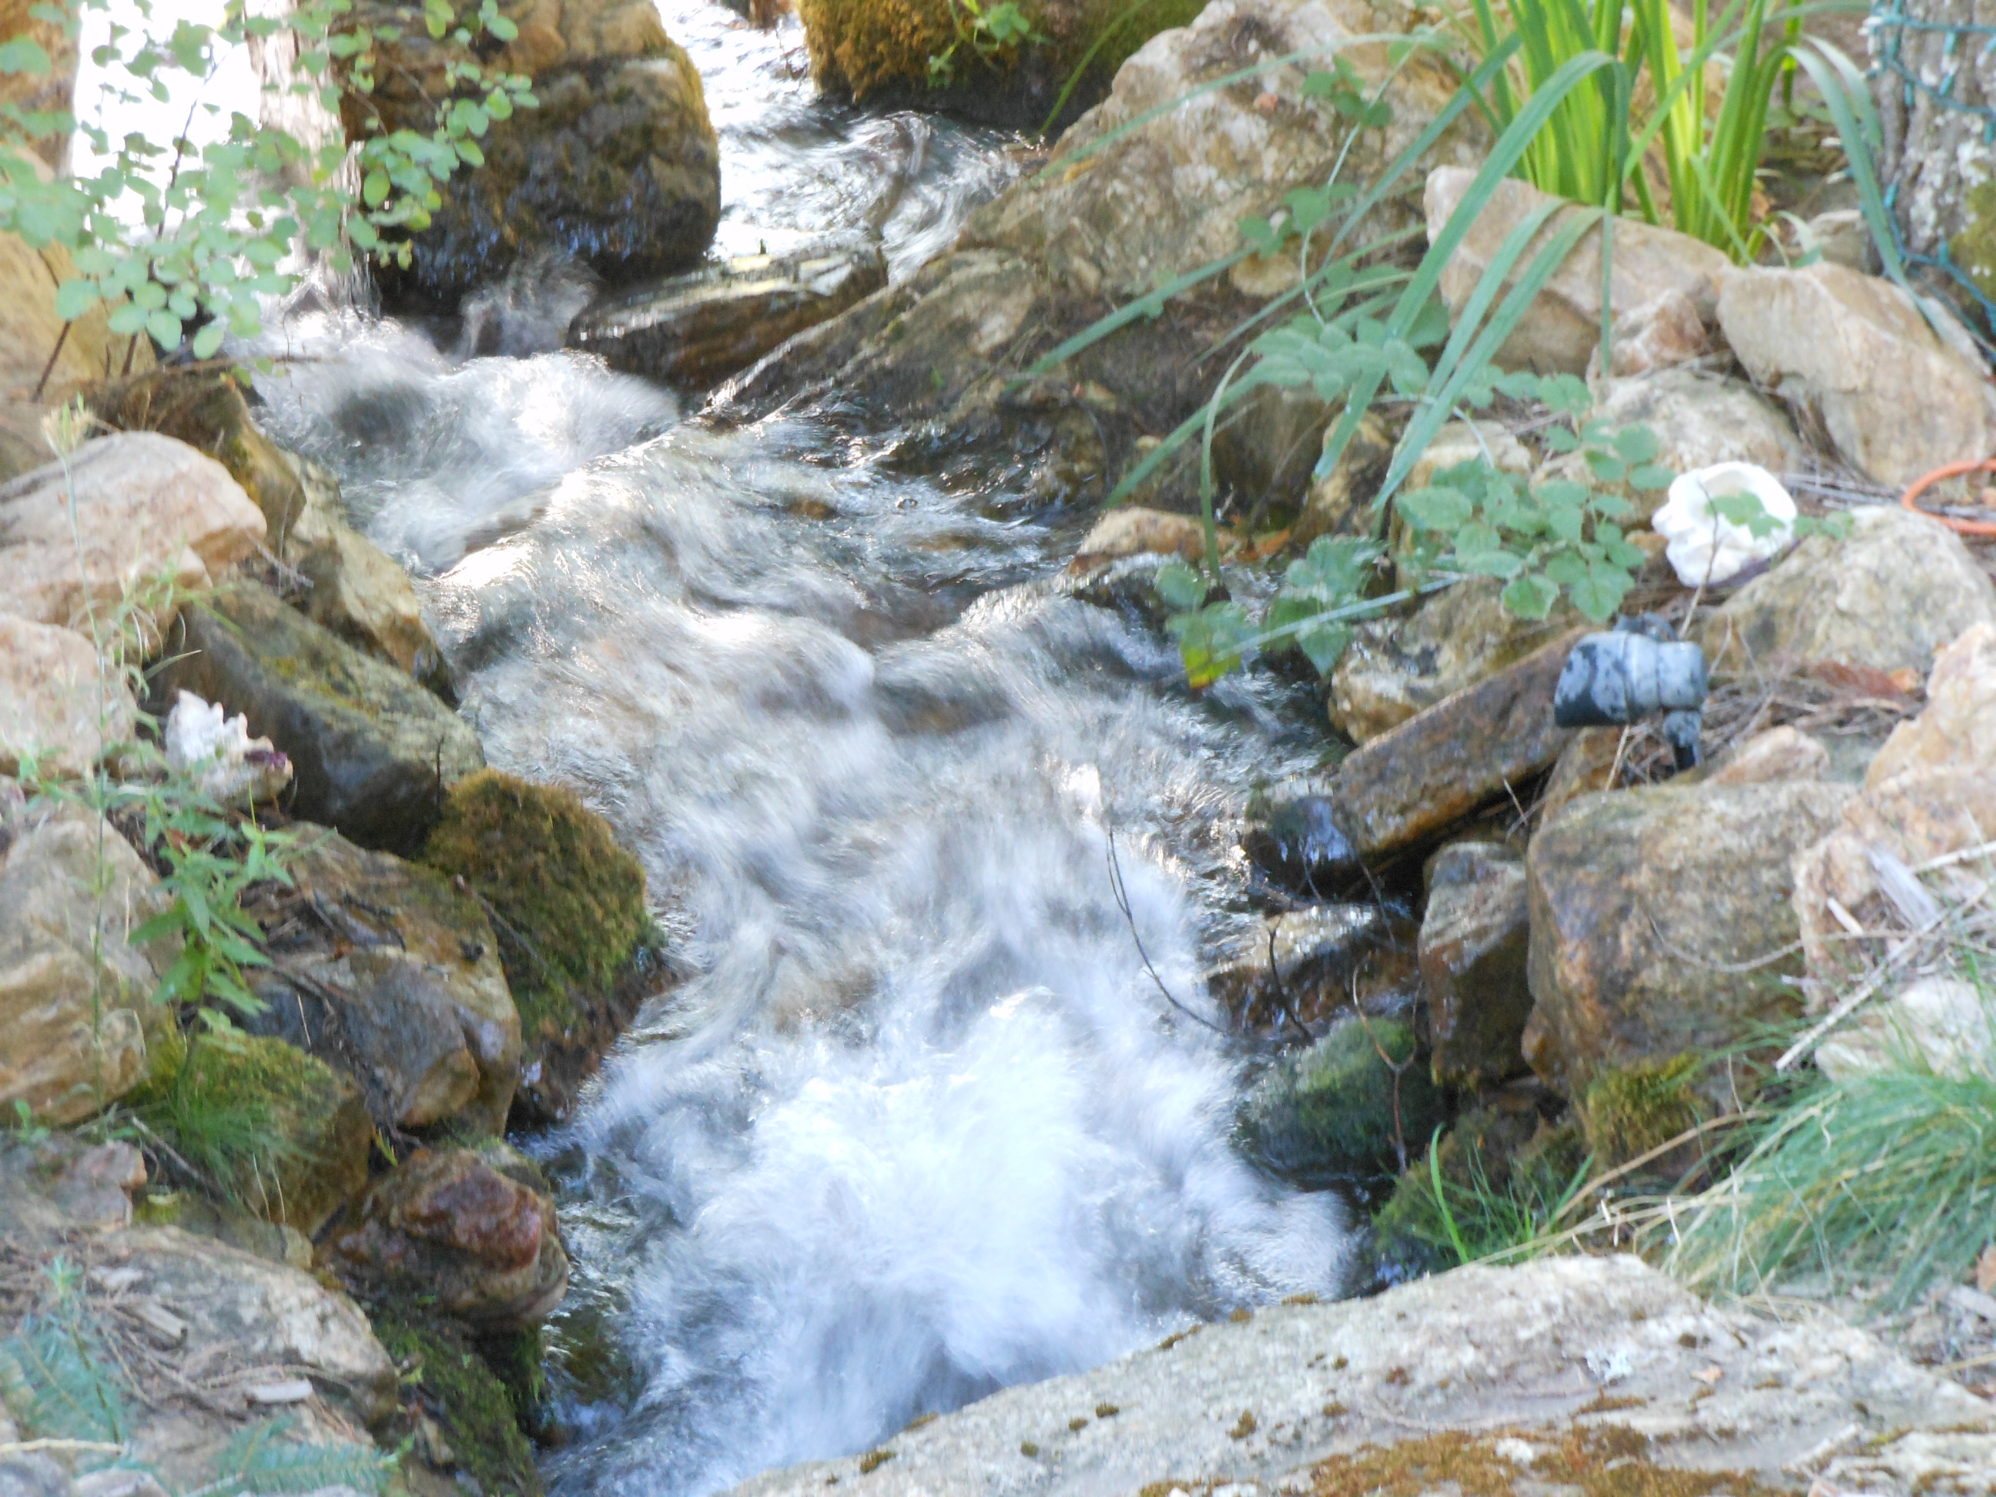
This shows the waterfall at the end of the 6" pipe that feeds pond #1 (9-27-11).

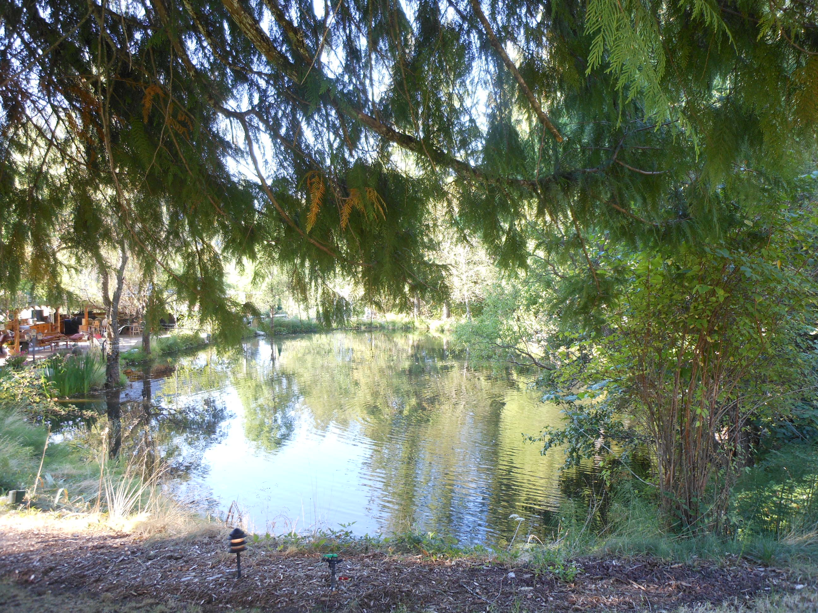
Pond #1 – 1970’s: The main pond, this is the pond that has the WR for 1 AF. Pond #1 then flows into a stream bed, down another waterfall to pond #2, it is the one that we put in 2001 (9-27-11).

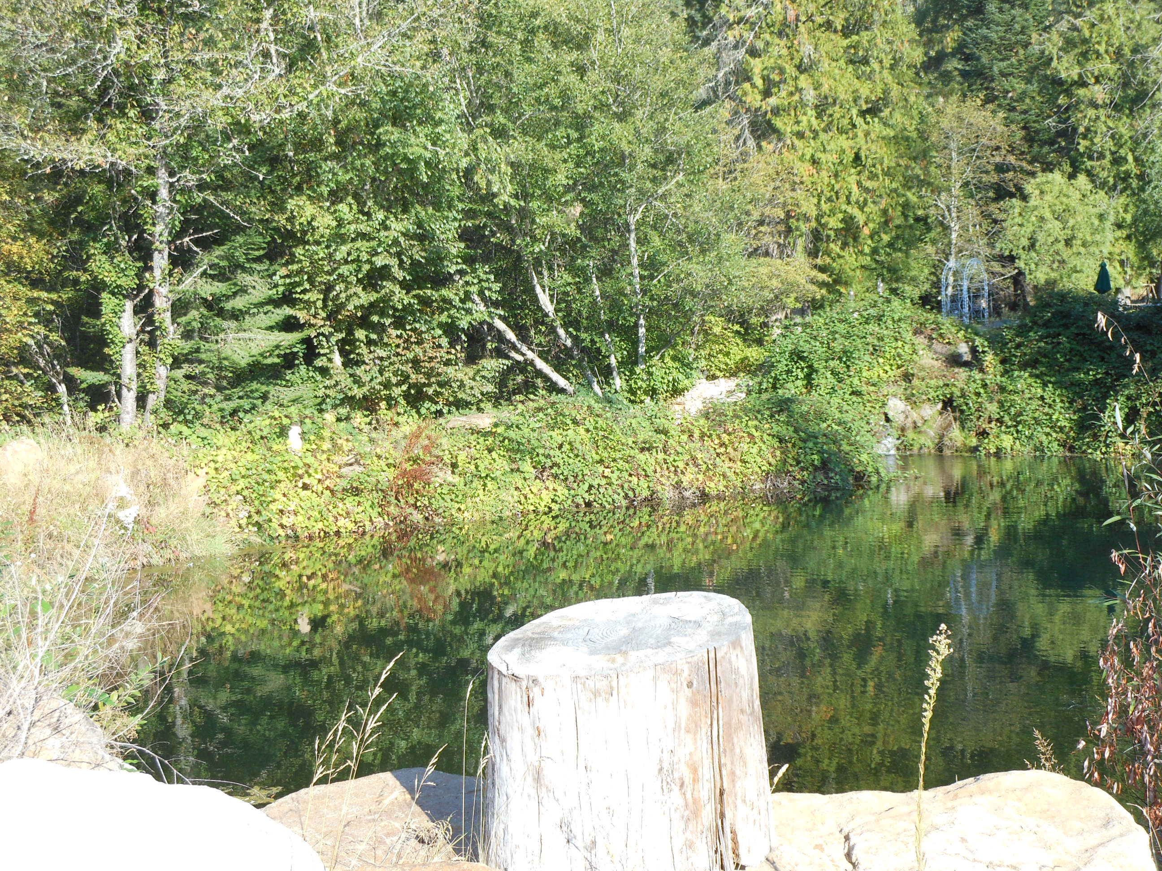
Pond #2 – 2001: This is a shot of the newest pond looking North (9-27-11).

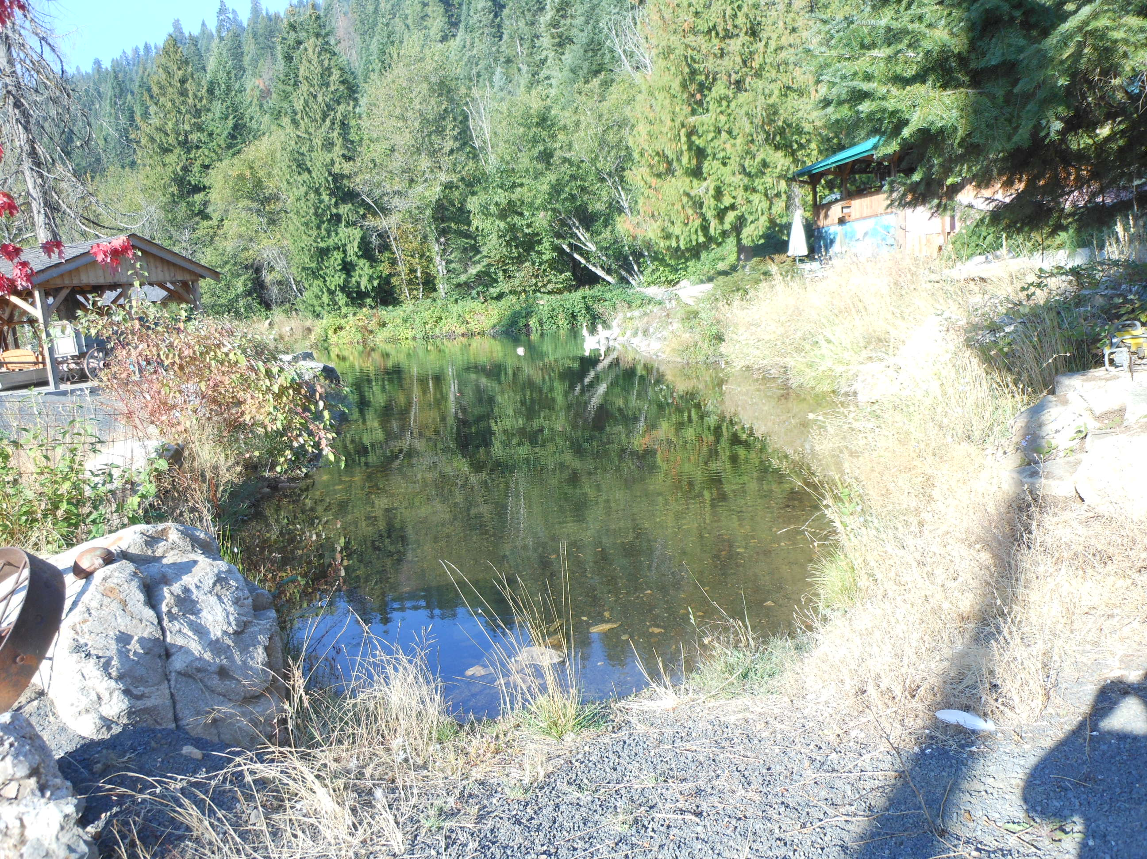
Pond #2: This is the same pond from the East end (9-27-11).

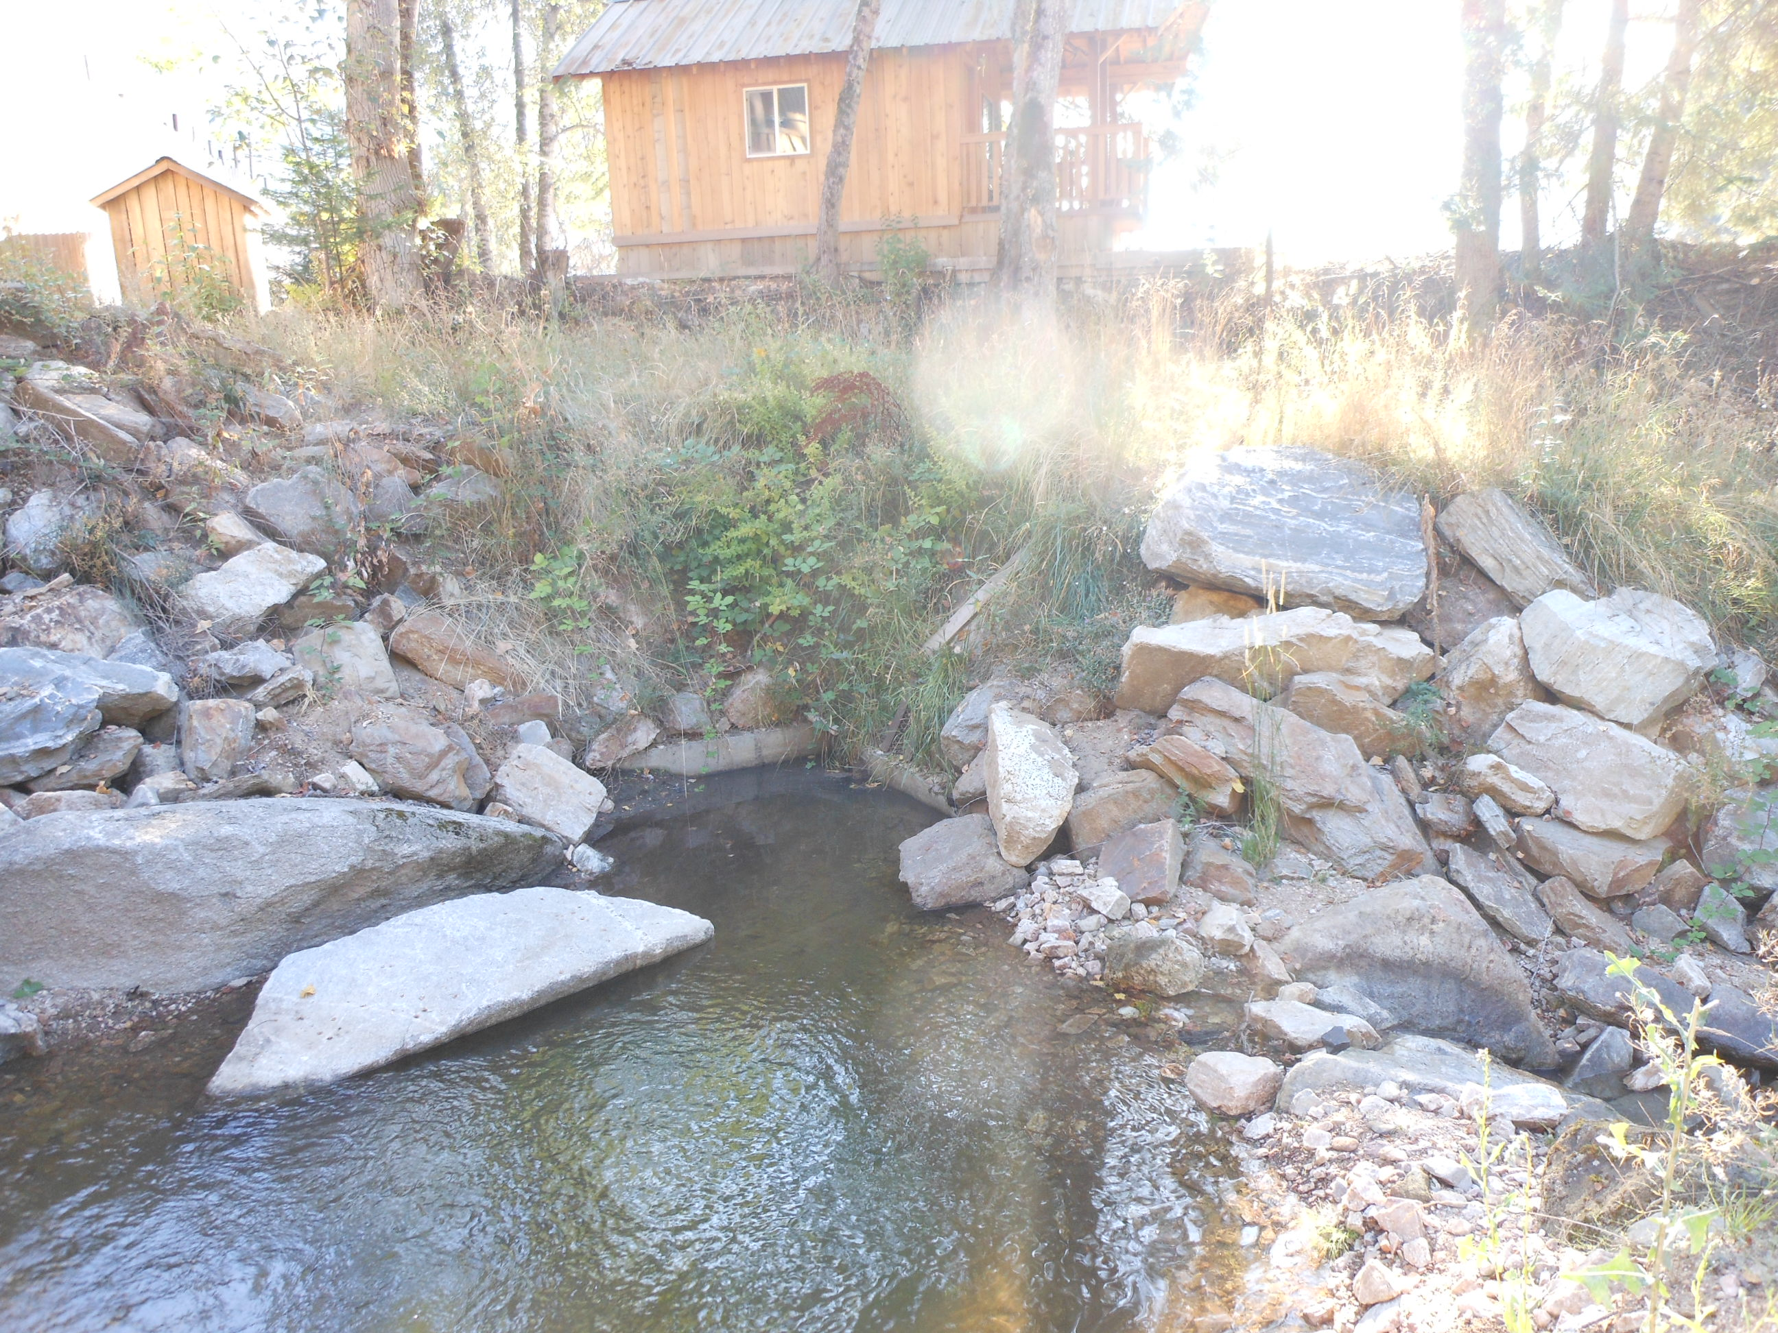
POD: This shows the overall view of the diversion site from Little Smith creek (9-27-11).

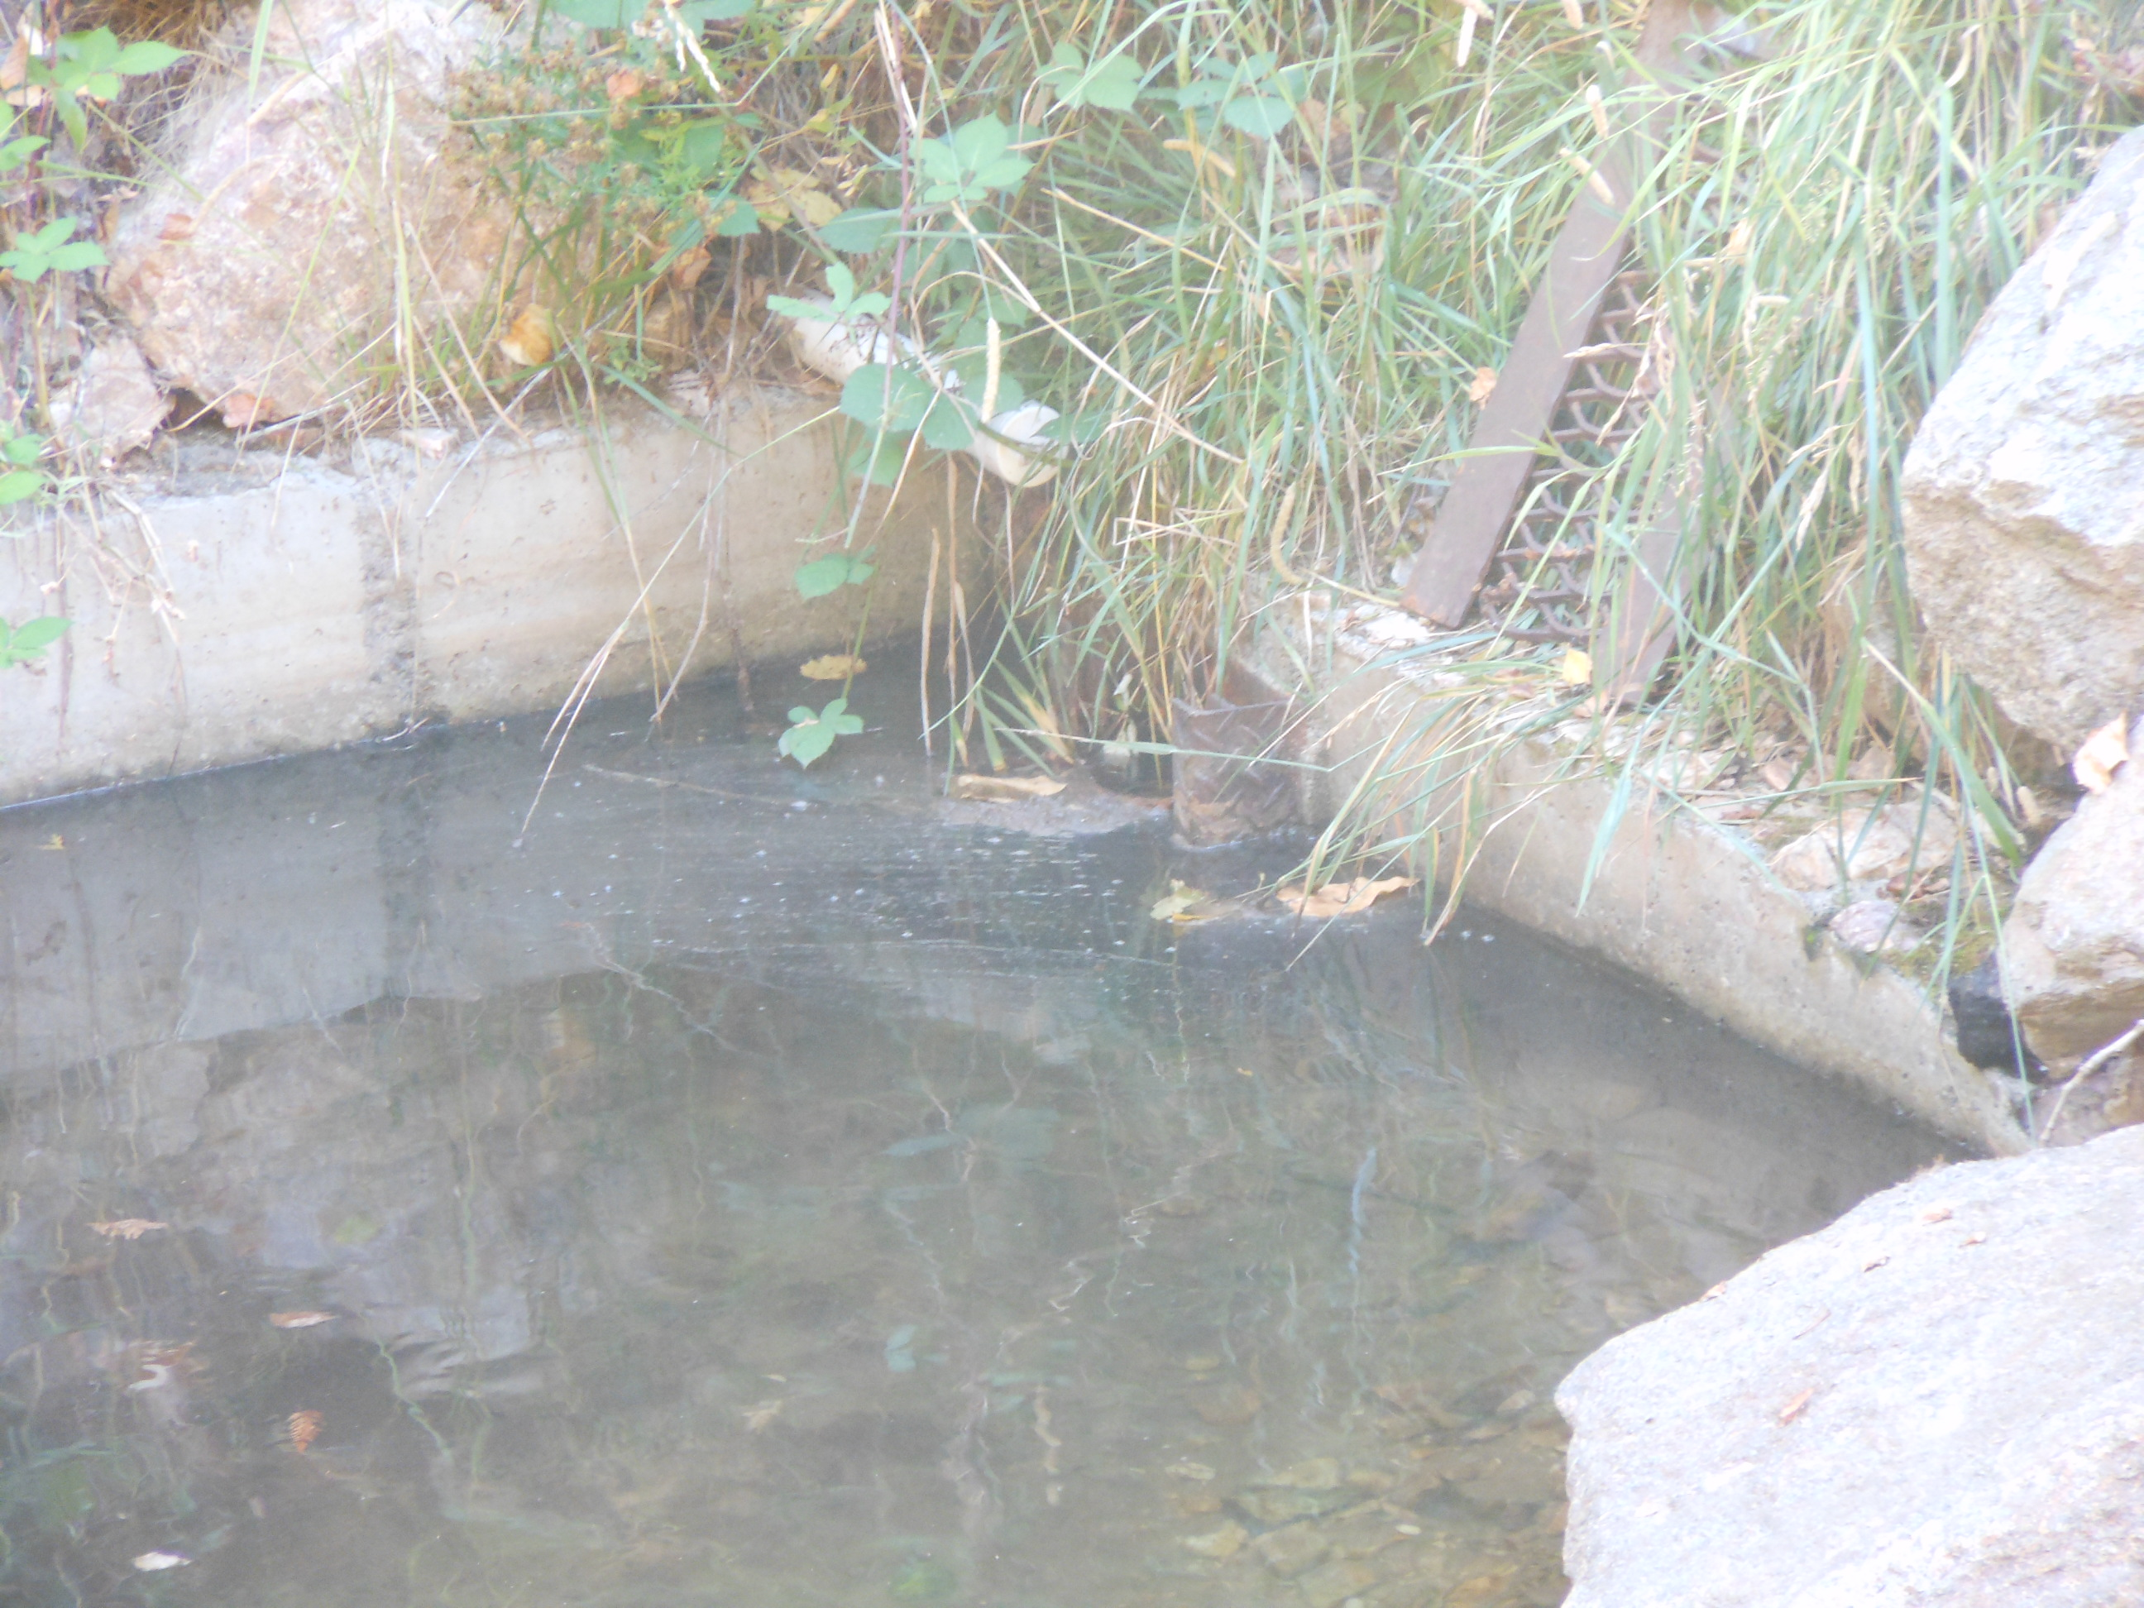
POD: This is just a closer view of the (POD) site (9-27-11).
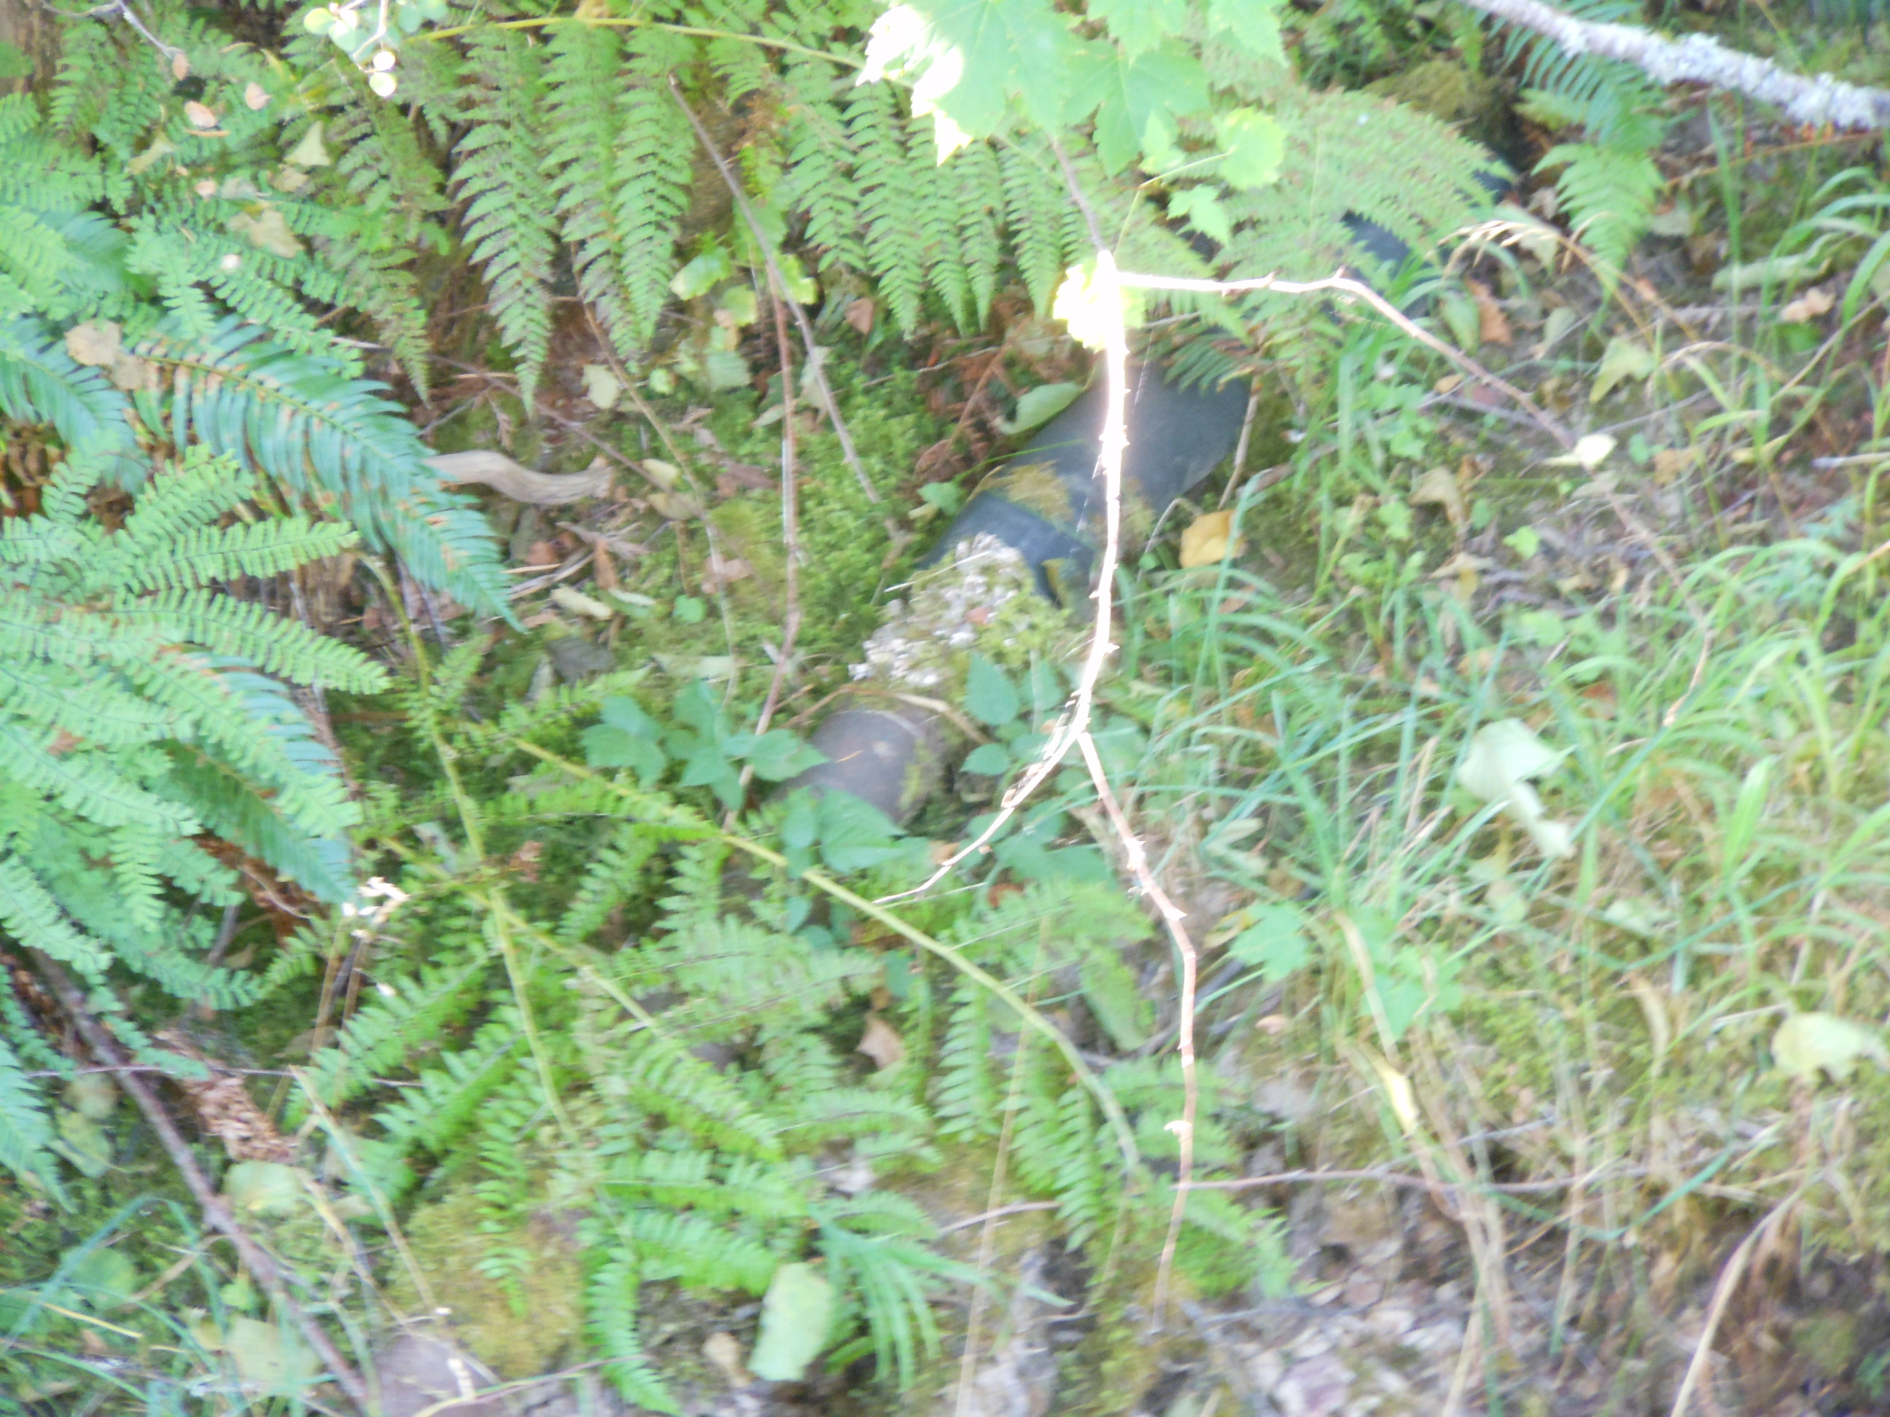
Photo of the old pipe adjacent to the creek (9-27-11).

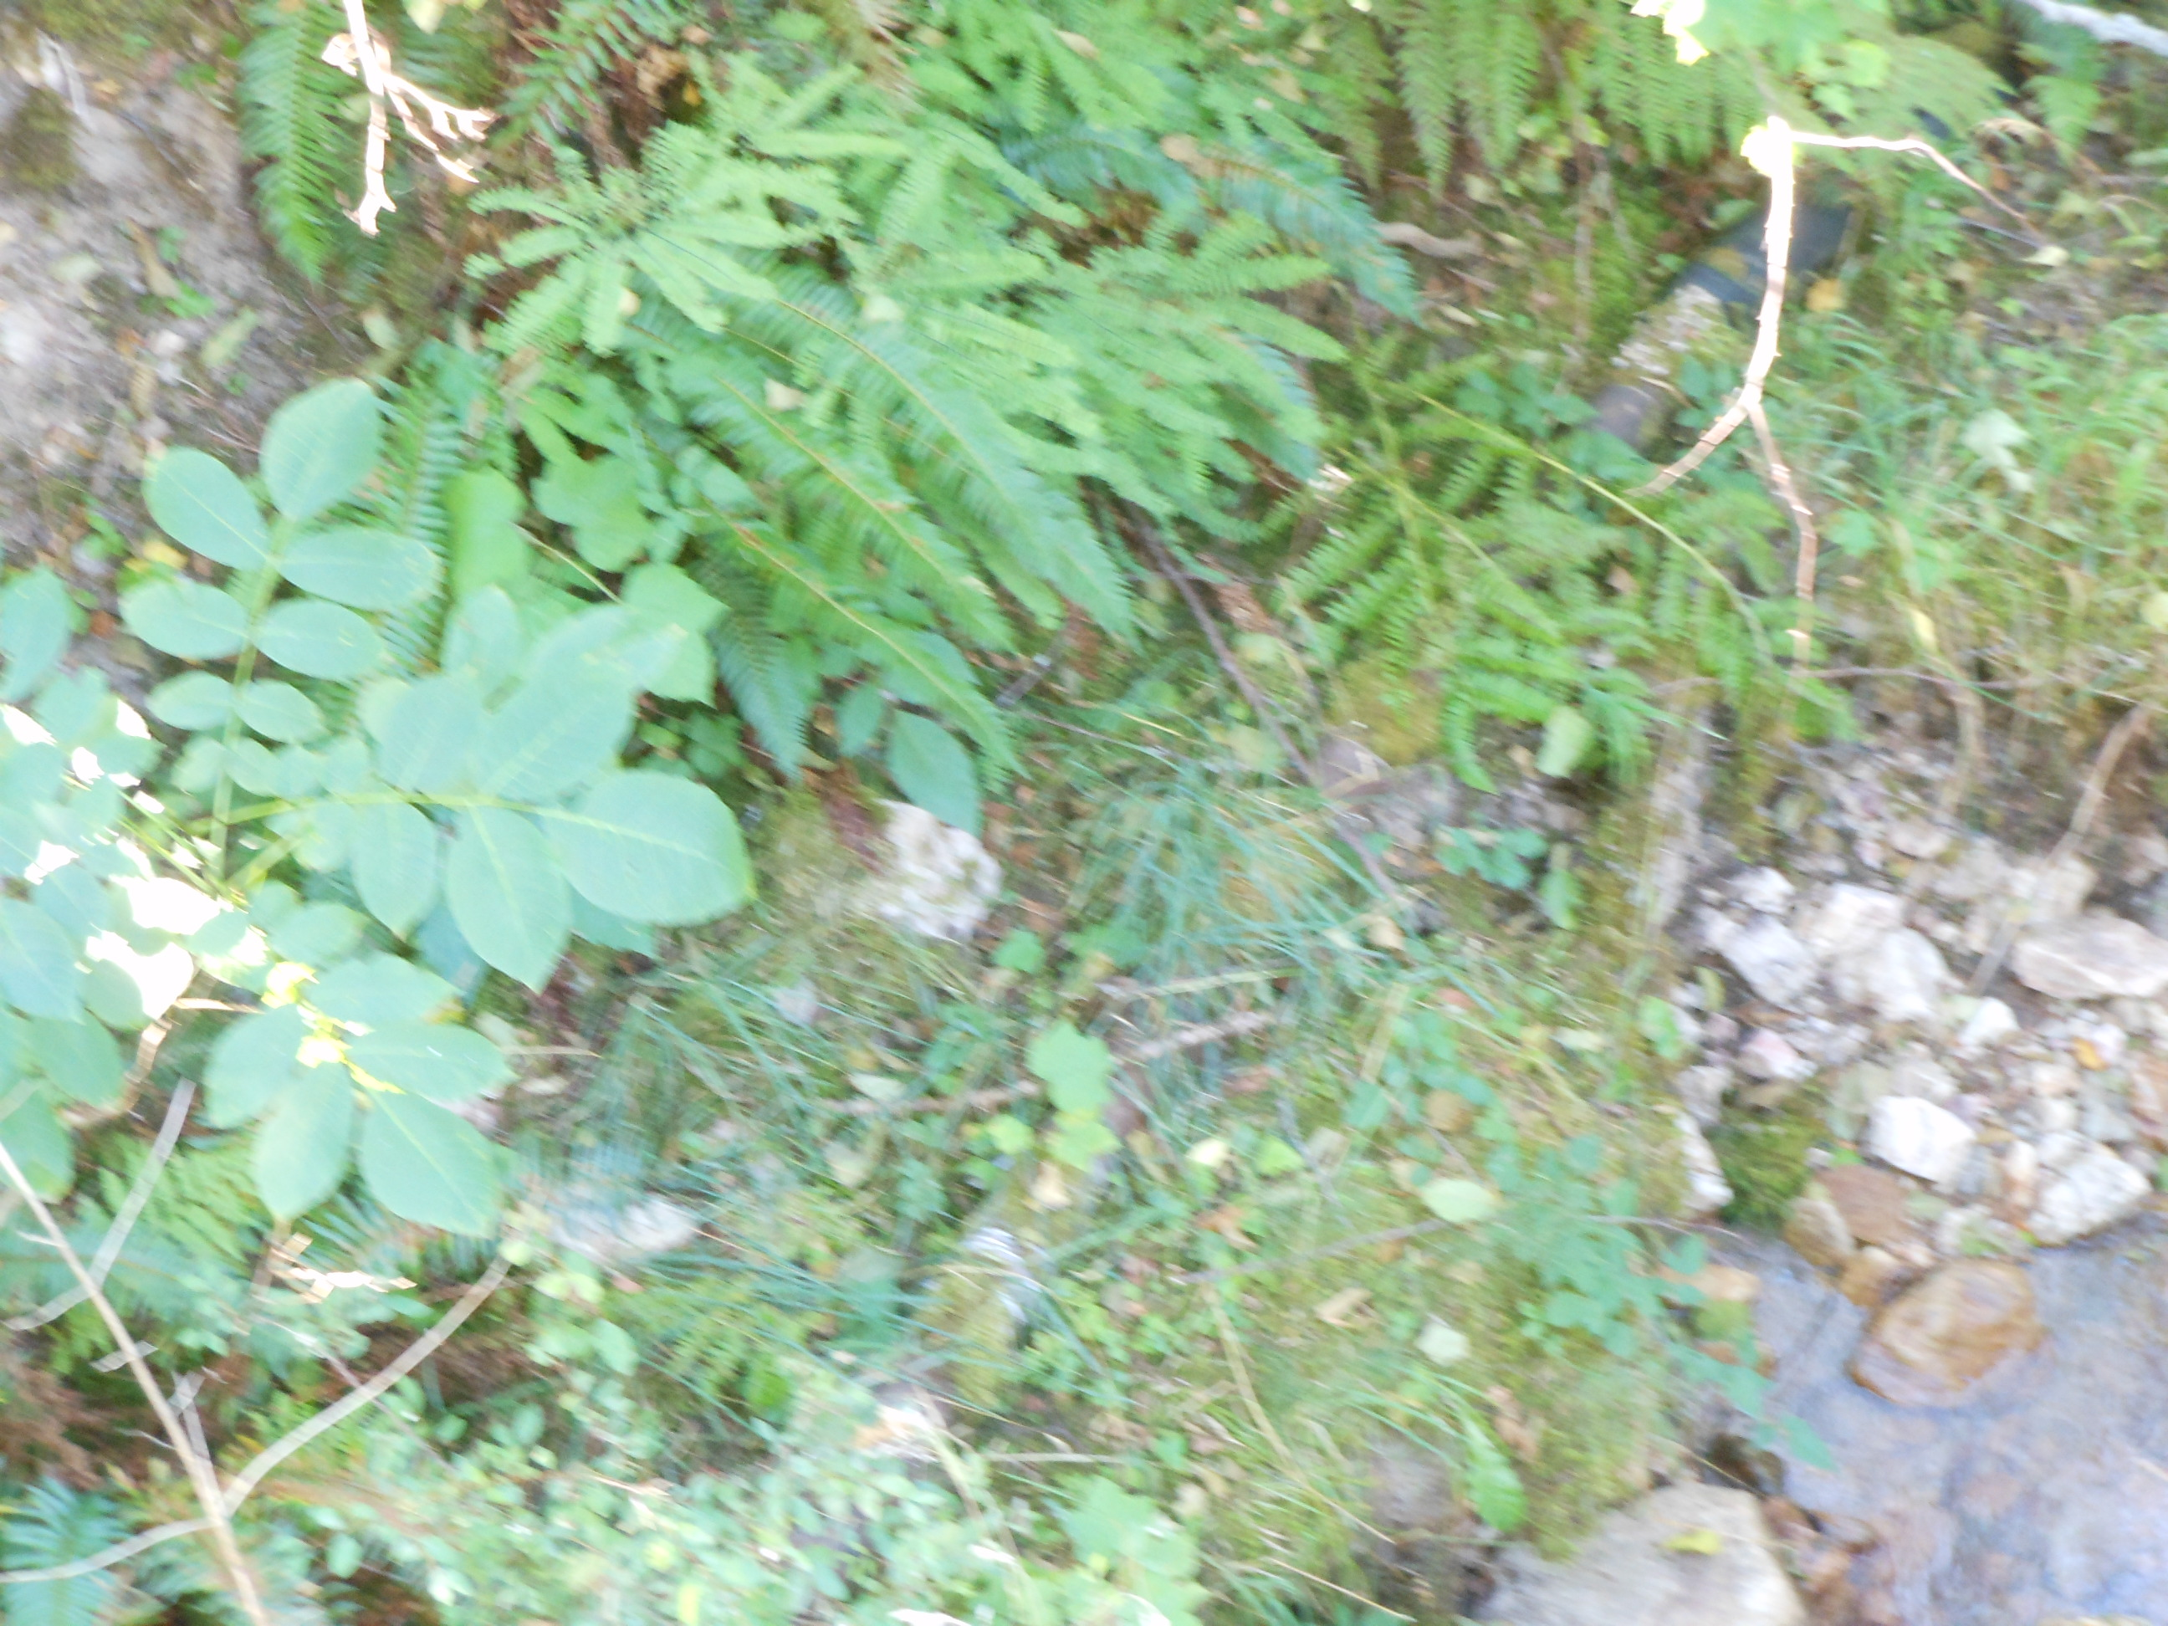
Some more of the old piping that still in place but no longer feeds the pond (9-27-11).

